🌐 DNS Caching
- Cache = temporary storage for frequently accessed data.
- DNS cache stores IP addresses and records locally → faster retrieval.
- Eliminates repeated network calls to DNS servers.
- TTL (Time to Live): defines how long cached data remains valid.
- Speeds up browsing but can serve stale data if source changes.
- Example: Visiting amazon.com twice → second request often served from cache.

📡 TCP/IP
- Transmission Control Protocol/Internet Protocol → foundation of internet communication.
- Breaks data into packets containing source and destination info.
- Packets may take different paths but are reassembled at destination.
- Ensures reliable, ordered delivery of complete messages.
- Happens extremely fast under the hood.

🔒 HTTP vs. HTTPS
- HTTP (Hypertext Transfer Protocol): standard for web communication.
- HTTPS (Secure HTTP): adds encryption via SSL/TLS.
  - Protects data from interception/tampering.
  - Uses certificates and public/private keys for secure session setup.
- Simplified HTTPS process:
  - Browser requests secure connection.
  - Server sends SSL/TLS certificate (with public key).
  - Browser validates certificate.
  - Browser generates session key, encrypts with server’s public key.
  - Server decrypts with private key → shared session key established.
  - All data exchanged is encrypted with session key.

⚙️ HTTP Methods
- Define actions clients can perform on resources (webpages, images, documents).
- GET: retrieve resources (e.g., loading a webpage).
- POST: send data to server (e.g., submitting a form).
- Other methods exist (PUT, DELETE, etc.), but GET and POST are most common.

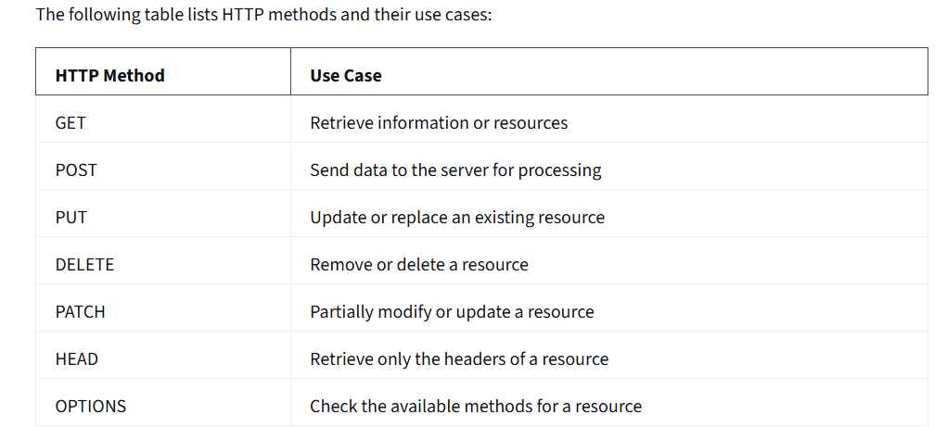

📑 HTTP Headers
- Extra information attached to HTTP requests/responses.
- Define details like:
  - Content type (HTML, JSON, etc.)
  - Content length
  - Encoding
  - Caching instructions
  - Authentication credentials
- Help browsers and servers interpret and process requests correctly.

🔢 Ports
- Ports identify connection endpoints for specific services.
- Each IP address can handle up to 65,535 ports.
- Common defaults:
  - HTTP → Port 80
  - HTTPS → Port 443
- Port numbers shown with a colon (e.g., https://amazon.com:443).
- Custom ports can be configured for different websites/services.
- Example: :444 → error if server not listening on that port.
- Common development ports: 8080, 8000.

📊 High vs. Low Ports
- Low ports (0–1023): well-known/system ports, restricted to authorized users.
- Examples:
  - 21 → FTP
  - 22 → SSH
  - 53 → DNS
  - 80 → HTTP
  - 443 → HTTPS
- High ports (>1023): often used for custom applications or development.

🔒 Firewalls
- Network security components that filter incoming/outgoing requests.
- Can be hardware, software, or cloud-based.
- Use ports to decide which traffic to allow or block.
- Example: configuring a web server requires opening port 80 for HTTP traffic.

